JCA-12 BEALE STREET
Beale Street – INTRODUCTION
Beale Street in Memphis (TN) is one of America’s most iconic streets. Beale Street is the birthplace of Blues. We’ve all heard of Memphis Blues and even if some of you have not, you have definitely heard this street mentioned in a few famous songs.

Marc Cohn’s world famous song “Walking in Memphis” mentions it in the chorus with the line “…walking with my feet ten feet off of Beale”.

B.B. King started here and was known as “The Beale Street Blues Boy”.

Beale Street is also a very important place in black history. Many clubs, restaurants and shops were owned by African-Americans. Between the 20s and 40s legends like Louis Armstrong, Muddy Waters, Albert King, Rufus Thomas and Rosco Gordon played on Beale and developed the Memphis Blues.

This is why we chose this Street as the name for our 12 Watt classic Blues Amp. The JOYO Beale Street is the kind of amplifier that would have been used by these musicians to shape the style of an era.

It is specially designed for guitar players who require a great and stable clean sound. It aims to perfectly reproduce the great American clean sound of the 50's.
Blues and Jazz players alike will find a new best friend on their quest for ultimate tone. It doesn’t hurt that it also looks extremely classy and original.

With its 12 Watt it is a great bedroom amp, perfect for recording and it even doesn’t leave you hanging at small gigs.

Features
●Classic 1950s 12 Watt vintage amplifier circuitry.
●Normal and bright channels with individual volume controls.
●Matched pair of 6V6 output tubes.
●One 5Y3 rectifier tube helps provide the natural compression or sag.
●Two high-gain 12AX7 preamp tubes, one of which may be substituted with a 12AY7 tube for the original 50s lower-gain sound, if desired.
The Beale Street is also your perfect companion when it comes to using pedals. Anything you throw in front of it will be amplified in greatest detail with amazing warmth and clarity.

In the below instructions, you’ll find many features of your Beale Street amplifier, as well as a guided tour of its front and rear panels, step-by-step instructions for setting up and using the amp. If you want to learn more about the full product line, please refer to our website www.joyoaudio.com
NOTE: In case your Beale Street amplifier needs maintenance, a Return Authorization (RA) number is required. Otherwise the maintenance service won’t be approved.

INSTRUCTIONS PERTAINING TO A RISK OF FIRE, ELECTRIC SHOCK, OR INJURY TO PERSONS.
The lightning flash with arrowhead symbol, within an equilateral triangle, is intended to alert the user to the presence of uninsulated “dangerous voltage” within the product’s enclosure that may be of sufficient magnitude to constitute a risk of electric shock to persons.
The exclamation point within an equilateral triangle is intended to alert the user to the presence of important operating and maintenance (servicing) instructions in the literature accompanying the product.

■Important Notes
■Read these instructions.
■Keep these instructions.
■Heed all warnings.
■Follow all instructions.
■Do not use this apparatus near water.
■Clean only with a dry cloth.
■Do not block any of the ventilation openings. Install in accordance with the manufacturers instructions.
■Do not install near any heat sources such as radiators, heat registers, stoves, or other apparatus (including amplifiers) that produce heat.
■Do not defeat the safety purpose of the polarized or grounding-type plug. A polarized plug has two blades with one wider than the other. A grounding type plug has two blades and a third grounding prong. The wide blade or the third prong are provided for your safety. When the provided plug does not fit into your outlet, consult an electrician for replacement of the obsolete outlet.
■Protect the power cord from being walked on or pinched particularly at plugs, convenience receptacles, and the point where they exit from the apparatus.
■Only use attachments/accessories specified by the manufacturer.
■Never use with a cart, stand, tripod, bracket, or table except as specified by the manufacturer, or sold with the apparatus. When a cart is used, use caution when moving the cart/apparatus combination to avoid injury from tip-over.
■Unplug this apparatus during lightning storms or when unused for long periods of time.
■Refer all servicing to qualified service personnel. Servicing is required when the apparatus has been damaged in any way, such as power-supply cord or plug is damaged, liquid has been spilled or objects have fallen into the apparatus, the apparatus has been exposed to rain or moisture, does not operate normally, or has been dropped.

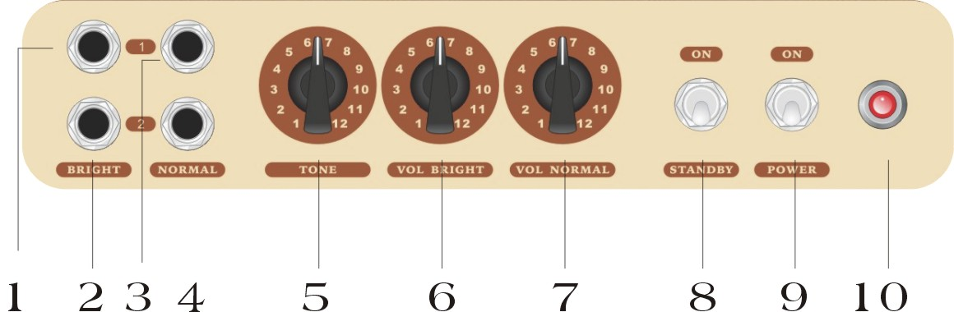
- BRIGHT INPUT JACK 1: Input for your guitar. Use input 1 (full sensitivity) with most guitars.
- BRIGHT INPUT JACK 2: Input for high-output/pre-amplified instrument for a darker tone, which provides a stronger treble response than the normal channel.
- NORMAL INPUT JACK 1: Input for your microphone or guitar. Use input 1 (full sensitivity) with most guitars.
- NORMAL INPUT JACK 2: Input for high-output/pre-amplified instrument for a darker tone.
- TONE: Adjusts the tonal characteristics of the amplifier.
- BRIGHT CHANNEL VOLUME: Adjusts the loudness of the bright channels.
- NORMAL CHANNEL VOLUME: Adjusts the loudness of the normal channels.
- STANDBY: When the standby switch is on, it will mute the amp output. Use standby during short breaks to reduce delay time caused by tube warm-up upon return to play. To extend the life of the vacuum tubes, use the standby function at least 60 seconds after turning on the amp.
- POWER: Turns the unit on or off as indicated by the LED light. When this switch is off, the amplifier is completely shut down.
- LED Indicator Light

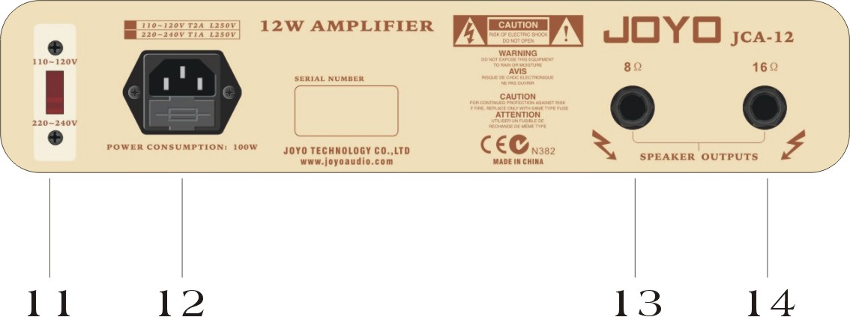
- Input voltage switch between 110-120V and 220-240V, make sure this is set to the voltage used in your country. When switch to the appropriate input voltage, please change to the corresponding fuse as well.
- Connect the included power cord to a grounded A/C outlet in accordance with the voltage and frequency ratings specified for your amplifier. Do not damage the grounding pin of the power plug, otherwise it may cause severe electric shock.
- 8Ωspeaker output socket.
- 16Ωspeaker output socket.
SETTING UP GUIDE
Setting up the amp for the first time is pretty simple and should only take you a few
minutes:
- Unpack and place it in an appropriate place (save the packaging material in case of future maintenance service). Typically this should be placed on top of a cabinet. To avoid potential overheating problems please make sure that the rear panel is unobstructed and there is good ventilation around the entire unit .
- Connect your cabinet to the speaker output with a speaker cable and make sure the impedance is matched.
- Plug in the power cable while making sure the power switch on the amplifier is in the OFF position.
- Use a standard music instrument cable to connect your guitar or effect pedals to the input jack on the front panel.
- On the front panel, make sure the Master Volume is set to minimum or a low setting, so you don’t get blown away when you turn on the amp.
- Turn on the amp, the LED light will be on, holding on for around 20 seconds or even longer to make the amp warm up before they can work, then turn on STANDBY switch to start to work.
- Set up your VOLUME on a low level; turn the TONE control up gradually to get the desired levels. Then turn the volume to appropriate level.
- Do the same for the other channel.
- Remember to switch the amp into standby when changing guitars or effects to avoid undesirable pops.

Now that it’s all setup, it’s time to experience your music journey.
If you encounter any difficulty in setting up or using your Amplifier, you can call JOYO (+86-755-29765381) between 9 a.m. and 5 p.m. (Time zone is Hong Kong), or contact your local dealer for technical help.

Specifications
1.Output power: (1 kHz, 8 ohm, 10%THD) 10W
2. Rated input level: (1 kHz) -20dBu
3. S/N ratio: (1 Wrms @ 1 kHz) 62dB
4. Dynamic range: (Rated output @ 1 kHz) 60dB
5. Signal gain: 43dB
6. Fuse type: Time-leg fuse
7. Fuse rating:
AC100-120V～60Hz T2AL
AC220-240V～50Hz T1AL
8. Weight: 8.5KG
9. Measurement: L (448mm) x W (196mm) x H (226mm)

